

### 

### [Description](http://vi.vipr.ebaydesc.com/ws/eBayISAPI.dll?ViewItemDescV4&item=351733016601&t=1463138899000&tid=210&category=4675&seller=sseariver2009&excSoj=1&excTrk=1&lsite=2&ittenable=false&domain=ebay.com&descgauge=1#)

**H1417 200M Digital Radio Station PLL Wireless Stereo FM Transmitter Module S**

Features:

Two-channel stereo FM transmitter

PCB size: 65x39x1.6mm

Transmitting distance: 50-200 meters

Operating voltage: 5-6V

Modulation mode: FM stereo two-channel(default tune in 107.9MHZ)

PLL phase-locked loop frequency stability (no frequency drift)

Output power: 100-600mW

Carrier frequency tolerance:± 500Hz

Modulation capacity: >± 100KHz

FM signal to noise ratio: > 60dB

AM parasitic noise: ≤50

Frequency response: 50Hz-15000Hz

Harmonic distortion:± 75 Hz at offset < 1% ± 100Hz frequency offset <1%

Rated deviation: ± 75KHz (100% modulation)

Ambient temperature: -10 ℃ - + 40 ℃

Package Included:

1x Module

### [Detail Image](http://vi.vipr.ebaydesc.com/ws/eBayISAPI.dll?ViewItemDescV4&item=351733016601&t=1463138899000&tid=210&category=4675&seller=sseariver2009&excSoj=1&excTrk=1&lsite=2&ittenable=false&domain=ebay.com&descgauge=1#)

[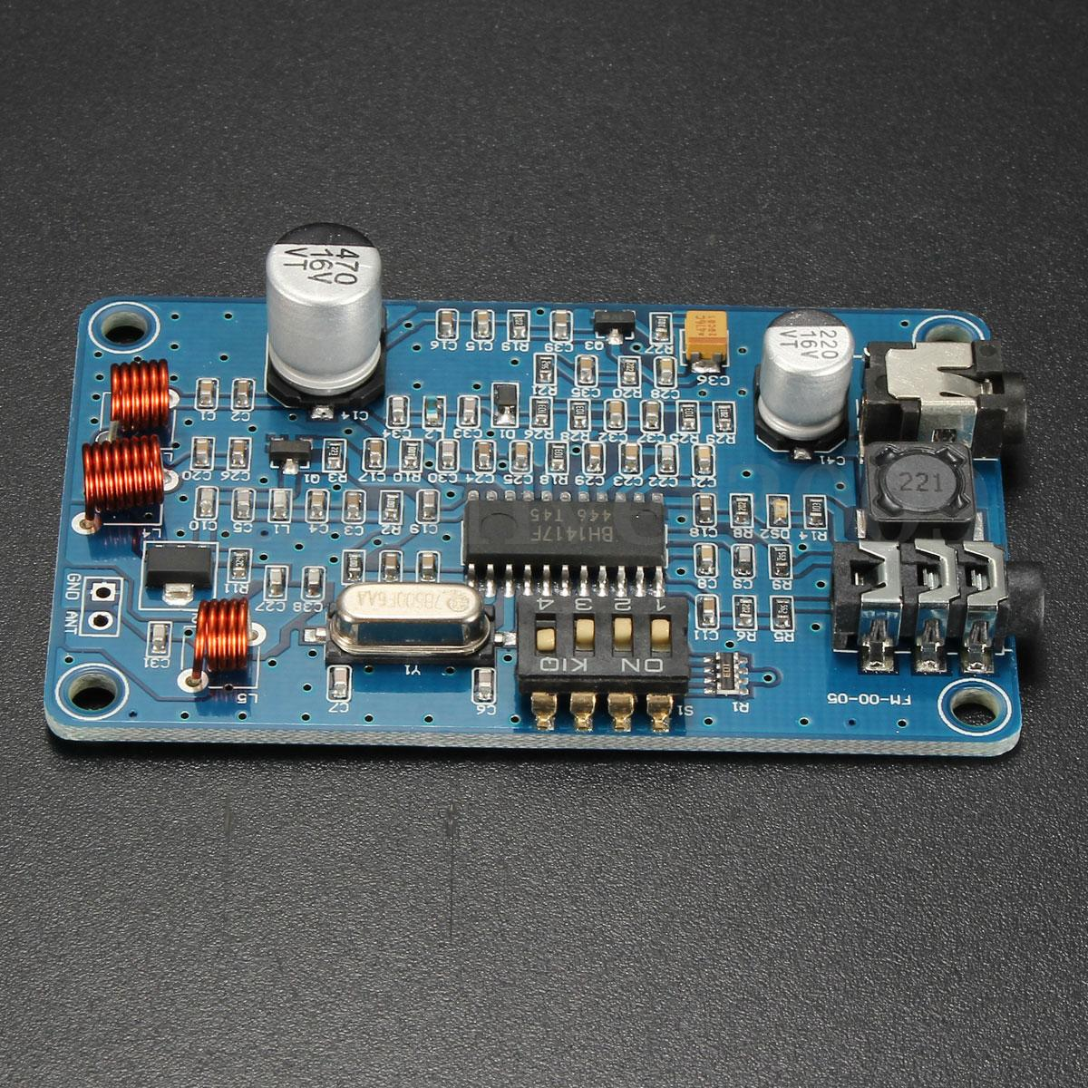](http://vi.vipr.ebaydesc.com/ws/eBayISAPI.dll?ViewItemDescV4&item=351733016601&t=1463138899000&tid=210&category=4675&seller=sseariver2009&excSoj=1&excTrk=1&lsite=2&ittenable=false&domain=ebay.com&descgauge=1#)

[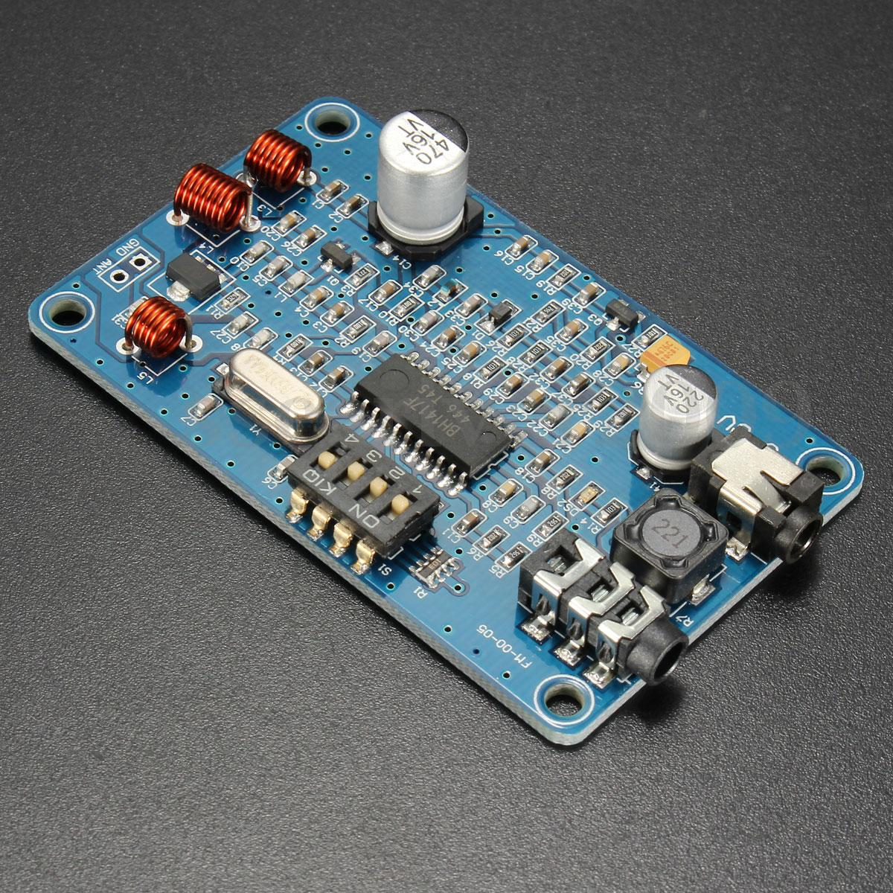](http://vi.vipr.ebaydesc.com/ws/eBayISAPI.dll?ViewItemDescV4&item=351733016601&t=1463138899000&tid=210&category=4675&seller=sseariver2009&excSoj=1&excTrk=1&lsite=2&ittenable=false&domain=ebay.com&descgauge=1#)

[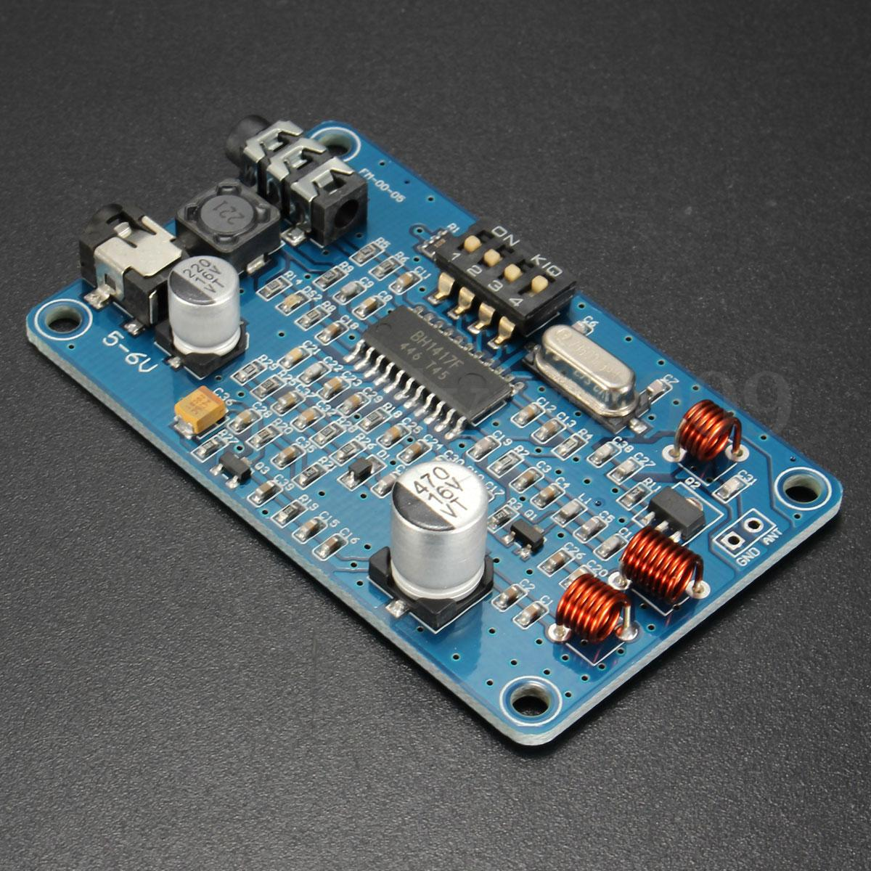](http://vi.vipr.ebaydesc.com/ws/eBayISAPI.dll?ViewItemDescV4&item=351733016601&t=1463138899000&tid=210&category=4675&seller=sseariver2009&excSoj=1&excTrk=1&lsite=2&ittenable=false&domain=ebay.com&descgauge=1#)

[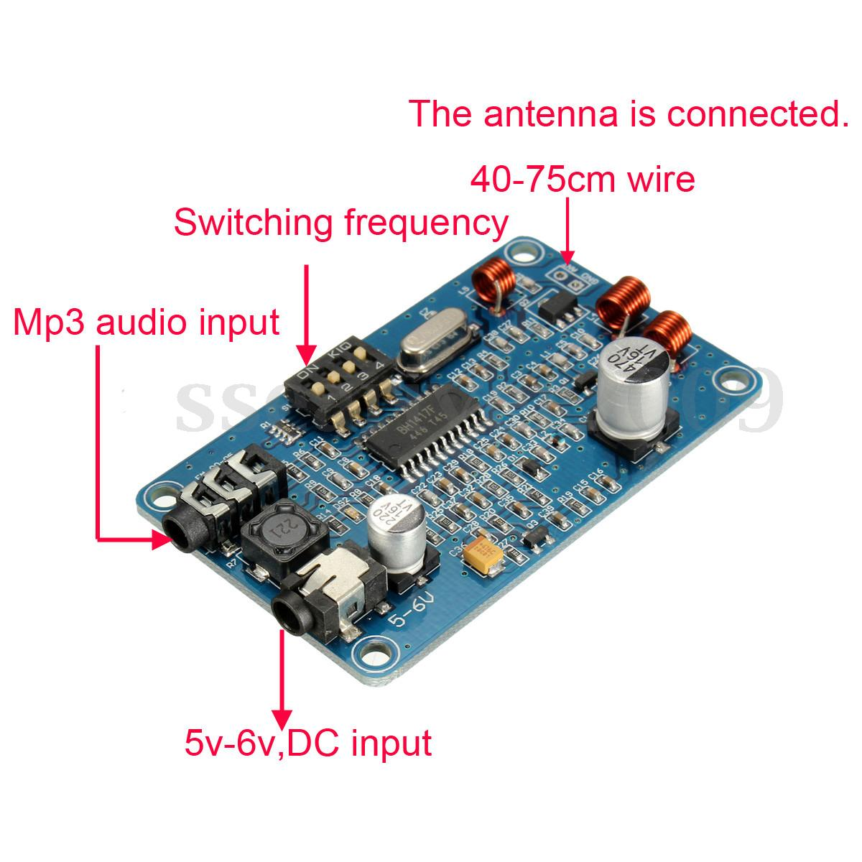](http://vi.vipr.ebaydesc.com/ws/eBayISAPI.dll?ViewItemDescV4&item=351733016601&t=1463138899000&tid=210&category=4675&seller=sseariver2009&excSoj=1&excTrk=1&lsite=2&ittenable=false&domain=ebay.com&descgauge=1#)

### [Payment](http://vi.vipr.ebaydesc.com/ws/eBayISAPI.dll?ViewItemDescV4&item=351733016601&t=1463138899000&tid=210&category=4675&seller=sseariver2009&excSoj=1&excTrk=1&lsite=2&ittenable=false&domain=ebay.com&descgauge=1#)

1.We accept PayPal only.

2.All major credit cards are accepted through secure payment processor PayPal.

3.Payment must be received within 7 business days of auction closing.

4.We ship to your eBay or Paypal address. Please make sure your eBay and Paypal address is correct before you pay.

### [Shipping](http://vi.vipr.ebaydesc.com/ws/eBayISAPI.dll?ViewItemDescV4&item=351733016601&t=1463138899000&tid=210&category=4675&seller=sseariver2009&excSoj=1&excTrk=1&lsite=2&ittenable=false&domain=ebay.com&descgauge=1#)

1.We ship to your eBay or Paypal address. Please make sure your eBay and Paypal address is correct before you pay.

2.Items will be shipped within 1-3 business day when we received payment.

3.Delivery time depends on destination and other factors;

4.International buyers please note:

a.Import duties, taxes and charges are not included in the item price or shipping charges. These charges are buyer’s responsibility. We will try our best to reduce the risk of the custom duties.

b.Please check with your country's customs office to determine what these additional costs will be prior to buying.